2. STEADY STATE THERMAL ANALYSIS

A steady state thermal analysis calculates a thermal response to specified heat loads subject to specified prescribed temperatures and/or convection conditions. It is used to determine temperatures, thermal gradients, heat flow rates and heat fluxes in an object that are caused by thermal loads that don’t vary over time. Such loads include the following
- Convections
- Radiations
- Heat flow rates
- Heat flux (heat flow per unit area)
- Heat generation rates (heat flow per unit volume)
- Constant temperature boundaries

2.1 Problem Description

As discussed in the previous chapter one of the possible cause for issue-1 that is Rocket not leaving the launcher tube may be due to of temperature mismatch. As Rocket consists of fuel that burns at a very high temperature in order to provide sufficient thrust. Fuel that burns at higher temperature may also lead to thermal expansion of the rocket body as well as launcher tube. Initially the rocket rests in the launcher tube as shown in the figure. There is initial gap of 0.5mm between rocket and launcher tube. If the radial expansion of the rocket is more than that of launcher tube then there will be chance of rocket getting stuck in the Launcher tube So steady state thermal analysis is conducted to investigate the results.

2.2 Steady State Thermal Analysis of Rocket

2.2.1 CAD model

All parts are designed and assembled in CATIA V5 Software and imported to ANSYS Workbench. CAD Model of the rocket is shown below
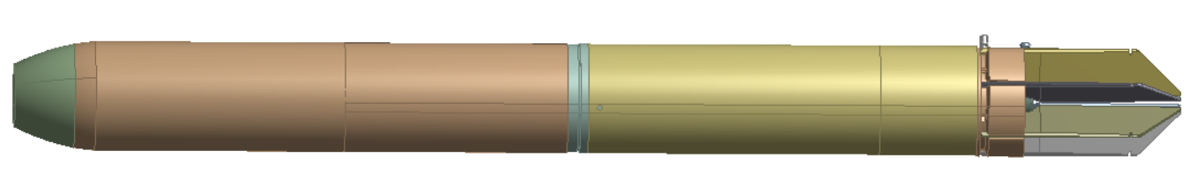
Fig 2.1 CAD Model of the Rocket Assembly

2.2.2 Mesh generation and Boundary Conditions

Hex dominant mesh is used for body and fuse adapter, tetrahedral mesh is used for the remaining parts of the assembly. Refinement of mesh is done by face sizing and body sizing of the parts. The meshed model is shown in the figure below.
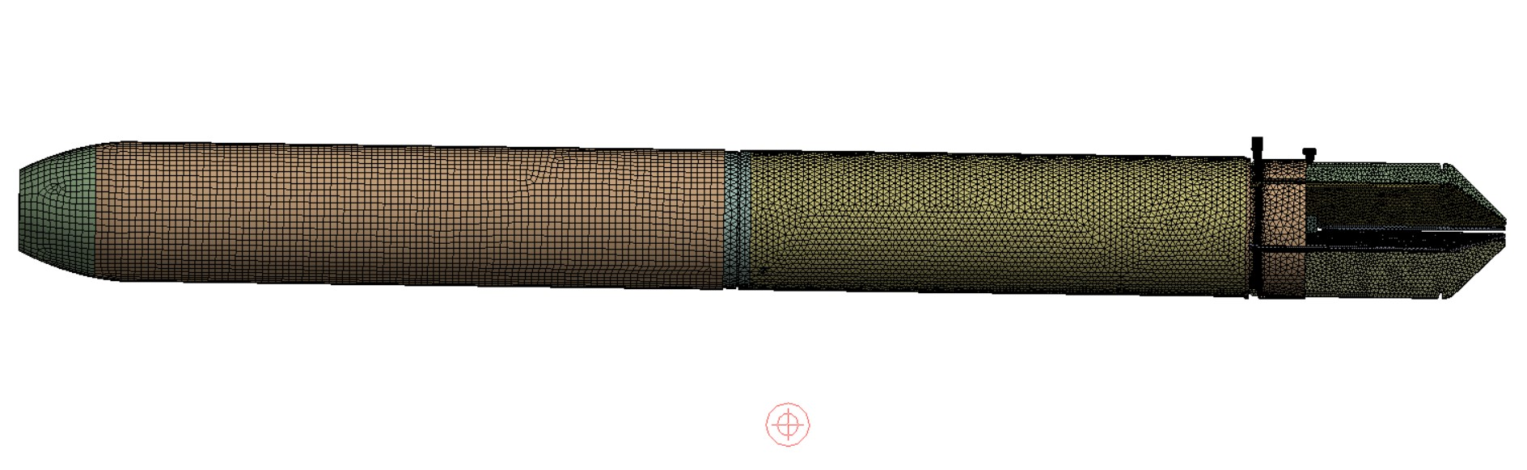
Fig 2.2 Meshed Model of the rocket assembly

For steady state thermal analysis, the boundary conditions are taken as the temperature at Fuse adapter as 40⁰C and the temperature at inner walls of motor tube up to 1/4th of its length is assumed to be 1000⁰C. (Since the motor tube contains the fuel that burns to provide thrust)
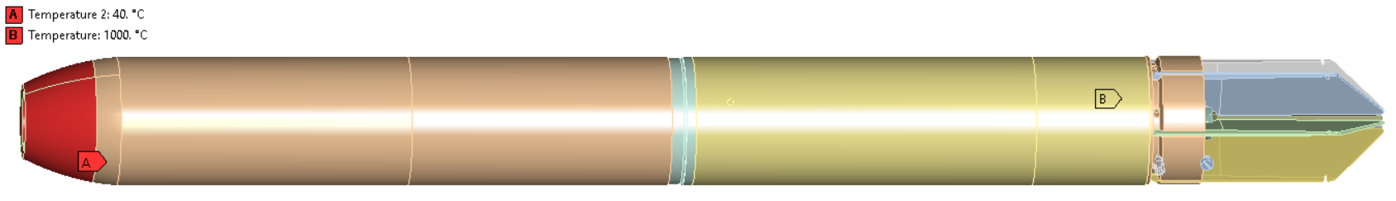
Fig 2.3 Assumed Thermal boundary conditions

In order to obtain the thermal stresses and thermal deformation, static structural analysis is done with the imported load as temperature distribution and the other boundary conditions as fixed supports at both the shear pin and stopper pin hubs since they are fitted in the launcher tube and frictionless support at the cross section where the rocket touches the launcher tube , the boundary conditions are shown in the fig 2.4, fig 2.5 and fig 2.6

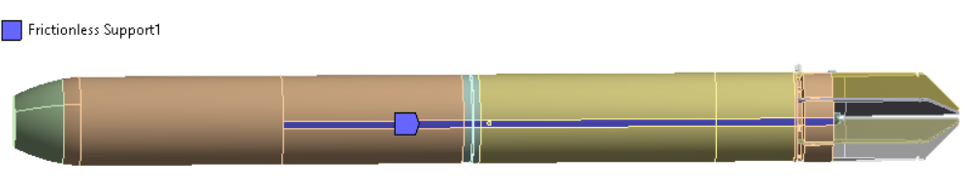
Fig 2.4 Showing Frictionless support
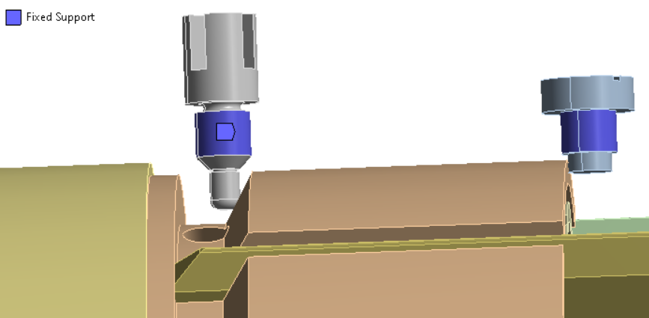
Fig 2.5 Showing Fixed supports
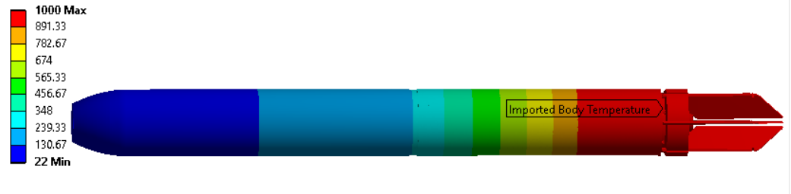
Fig 2.6 Imported body temperature of the rocket

2.2.3 Temperature distribution of rocket

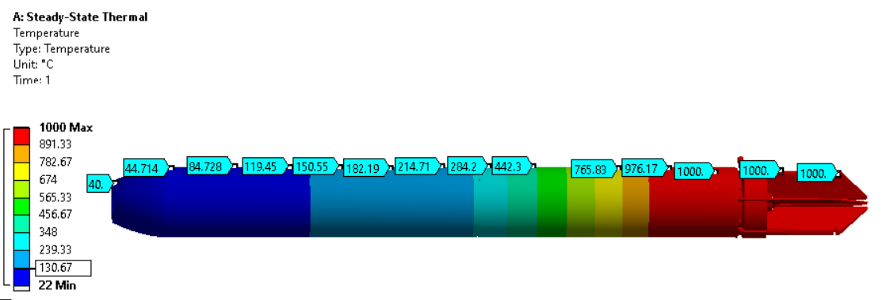
Fig 2.7 Temperature distribution of the rocket

2.2.4 Directional Deformation of the rocket

Since the rocket is placed in the launcher tube there will be no deformation on the bottom side where the rocket sits in the launcher tube. The directional deformation along the radial direction is shown in the fig 2.8
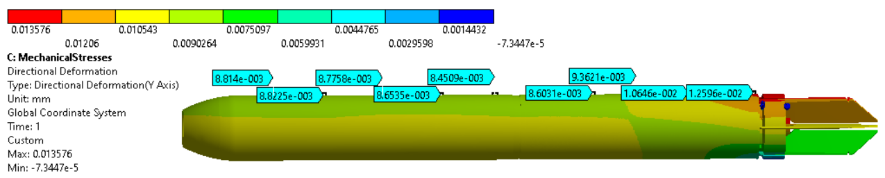
Fig 2.7 Directional deformation of rocket along the radial direction

2.3 Thermal Analysis of Launcher Tube

2.3.1 CAD model of Launcher tube
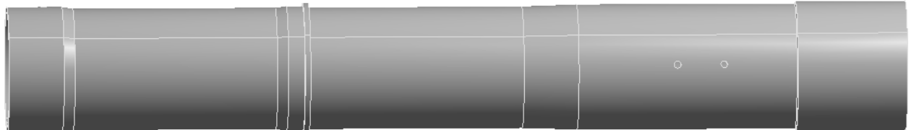
Fig 2.8 CAD Model of the Launcher Tube

2.3.2 Mesh generation and Boundary Conditions

Due to the irregularities in the geometry hex dominant mesh cannot be applied so tetrahedral mesh is applied
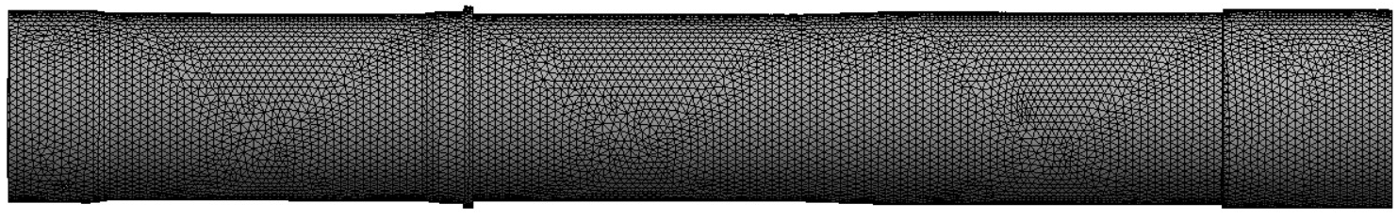
Fig 2.9 Meshed Model of the Launcher Tube

Temperatures that are obtained from the surface of the rocket are taken at four different locations by average and are applied at the corresponding lengths on the inner walls of the launcher tube. Boundary conditions applied are as shown in fig 2.10
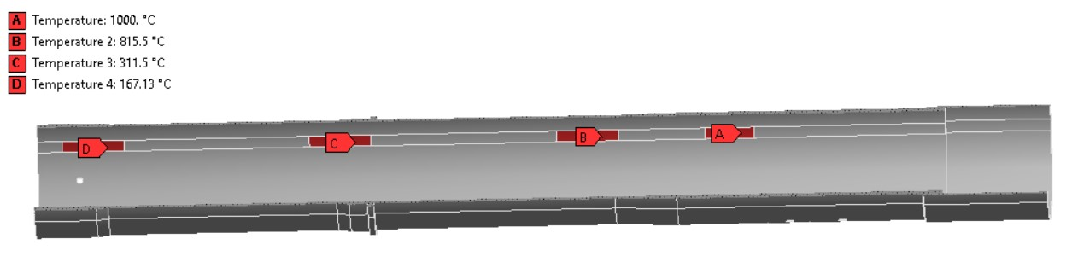
Fig 2.10 Sectional view of Launcher tube showing boundary conditions

Similarly, to obtain the thermal stresses and thermal deformation of the launcher tube static structural analysis is done with the imported load as temperature distribution and the other boundary conditions as fixed support at the shear pin hole and frictionless support at the bracket for front support as shown in fig 2.11 and fig 2.12
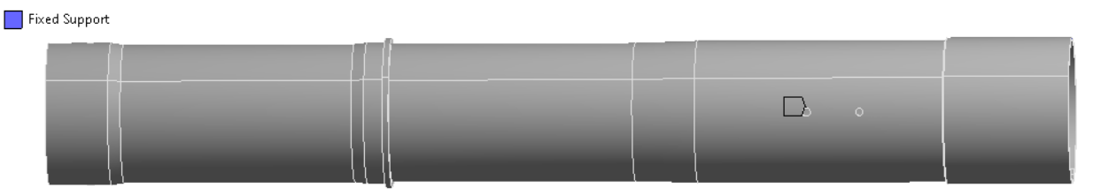
Fig 2.11 Showing Fixed support at the shear pin hole
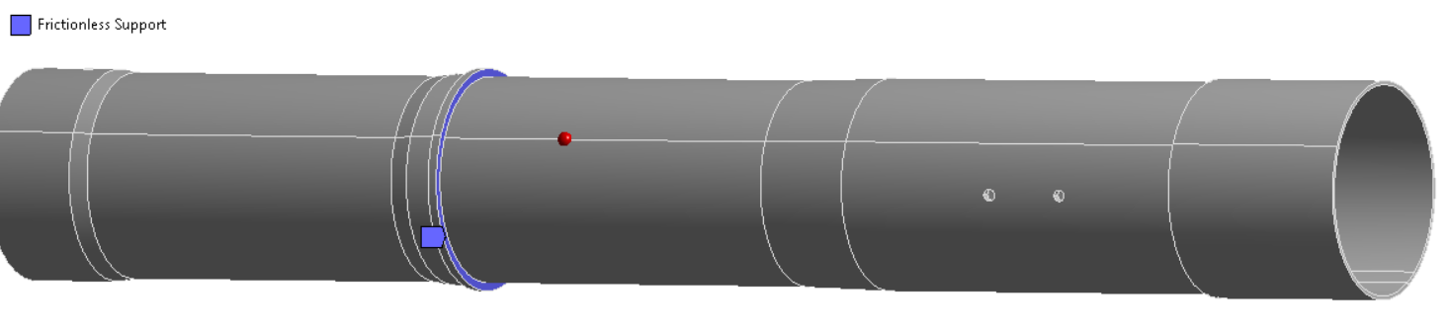
Fig 2.12 Showing Frictionless support at bracket for support

2.3.3 Temperature distribution of Launcher tube

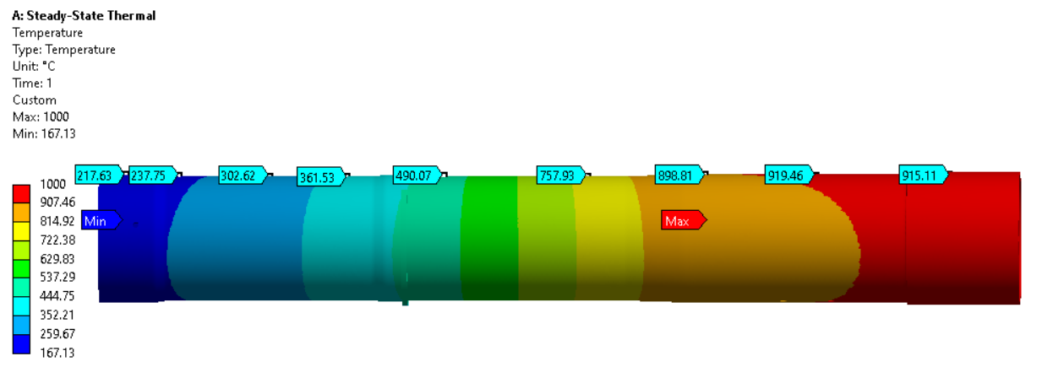
Fig 2.13 Temperature distribution of launcher tube
.

2.3.4 Directional Deformation of the rocket

As launcher tube is free to expand in the both the directions radially the sectional view of the radial deformation is shown in the fig 2.14
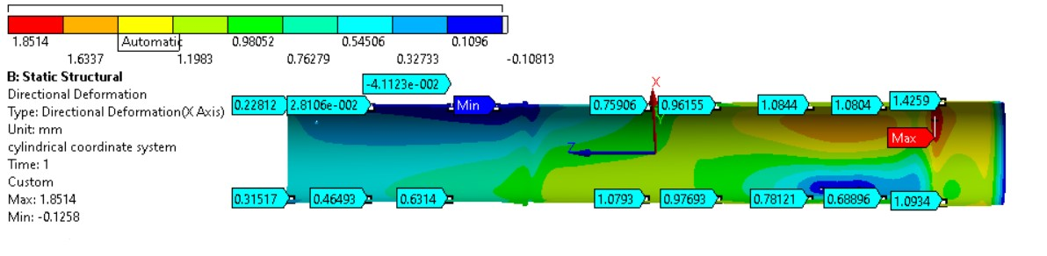
Fig 2.14 Directional deformation of Launcher tube along the radial direction

2.4 Comparison of Radial expansions of rocket and launcher tube

Initially, the gap between rocket and launcher tube is 0.5mm. By analysis, Radial expansion of Launcher Tube is more than that of the Rocket. The minimum gap between the rocket and the launcher tube is 0.98435mm. Hence, Rocket doesn’t get stuck in the Launcher Tube. Pictorial representation of comparison is shown in fig 2.8
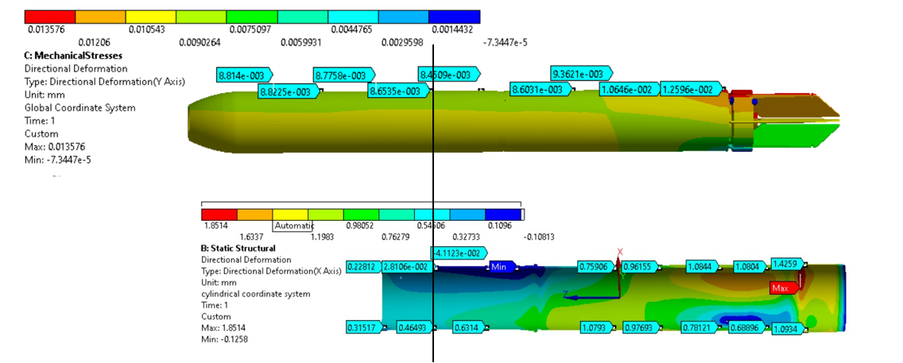
Fig 2.15 Comparison of Radial expansions of rocket and launcher tube

